Activity 11.4 Submission

1. 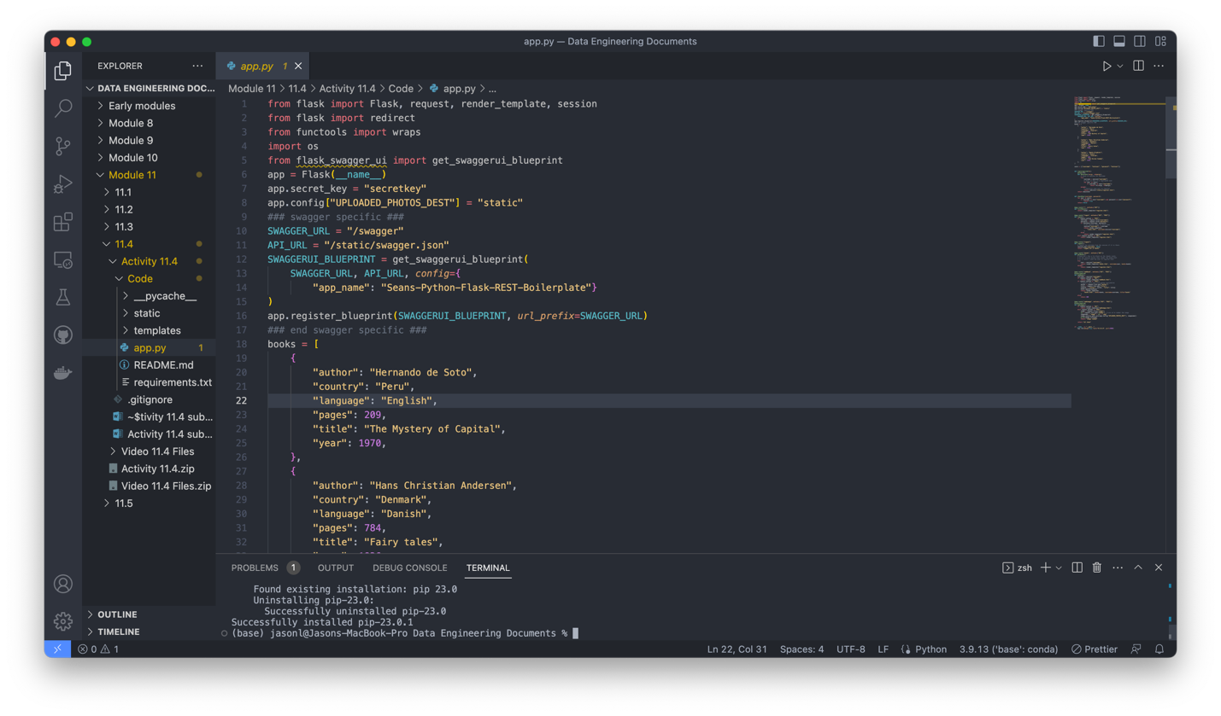
   1. Screenshot showing opened app.py from activity 11.4
2. Graphical user interface, application, Teams

   Description automatically generated
   1. Screenshot of accessing the server through local host 4999. I need to use 4999 because I am on mac Monterey 13 and 5000 is used by Apple for handoff between other devices. I do not wish to turn that feature off so I will continue to use 4999 or 3000 in the future.
3. Graphical user interface, application

   Description automatically generated
   1. Screenshot of localhost:4999/swagger/
4. Graphical user interface, text

   Description automatically generated
   1. Screenshot of GET request for books. I ended up turning airplay receiver off because swagger was not updating the base URL after I edited the swagger.json file. I do not know why it would not update and it made me mad enough to change my settings temporarily.
5. Graphical user interface, text

   Description automatically generated
   1. Screenshot of POST request to add my new book. The output was scrolled to view the book I created was successfully added to the database. I did need to go back into the regular instance and login with testuser before I was able to execute this successfully.